Classroom Carbon Dioxide Concentrations: Inside classrooms
Student Handout

Research Question:
How does the concentration of carbon dioxide in a classroom change over time depending on changes in population and other environmental factors?

Hypothesis:
“I think the level of carbon dioxide in the classroom(s) will _____________ over time. The population and environmental factors that affect these spaces over time are _____________.

Materials:
- Gastec Gas Sampling Pump
- Carbon Dioxide detector tube (2EL) (2-4)
- Carbon Dioxide detector tube (2EH) (2-4)
- Material to gather:
- Map of classroom(s) in school (Poster Size)
- Meter sticks

Procedures:
- Draw a map showing the environmental factors that may have an effect on the carbon dioxide level in the room over time. Look for sources of ventilation such as heaters and air conditioners.
- Make a 24 hour schedule that shows the time that any of these environmental factors change. (e.g. 7 a.m. door opens, 8:30 a.m. heater turns on)
- Make a 24-hour schedule timeline that shows the approximate number of people occupying the room.
- Choose a location and the time of day to measure the carbon dioxide concentration. Mark the location on the map.
- Measure the amount of carbon dioxide concentration for the location by holding the pump 1 meter above the floor. Be sure to hold the pump and tube still for 1 minute before reading the measurement. Use carbon dioxide detector tube (2EL) first. If the reading exceeds the range, use carbon dioxide detector tube (2EH).
- Record the percent of carbon dioxide and time in the table.
- Record data and time on the large class map.
- Share and collect data from other small groups for the table as well.

Data Table for Carbon Dioxide Levels in Classroom(s)
Location | Carbon Dioxide Level | Time | Population | Observation of Environmental Factors
 | %
 | %
 | %
 | %
 | %
 | %
 | %

Analyzing Data:
- Make a map of each location that shows the carbon dioxide level and time the reading was made.
- Construct a graph showing the relationship between location and carbon dioxide concentrations.
- Construct a graph showing the relationship between time of day and carbon dioxide concentrations.
- Construct a graph showing the relationship between the number of people and the carbon dioxide concentration.
- Locate any patterns.
- Do any locations exceed the recommend exposure limit of 0.1%?
- Make inferences regarding the cause of any differences in carbon dioxide concentrations.

Discussion of Results:
- Restate your hypothesis.
- Explain how the data supports or does not support your hypothesis with specific measurements, calculations or patterns.
- Does the amount of carbon dioxide meet or exceed the exposure limits?
- Describe any cause and effect relationships between time of day, population and environmental factors that effect the concentration of carbon dioxide. Give specific examples.
- How can the experimental design be improved to improve the data?
- What is the significance of these results? Identify any person or community health concerns that need to be addressed. Recommend a solution.
- Which research question might be explored next based on these findings?

Background on Indoor Air Quality

The cycling of carbon dioxide in earth’s atmosphere depends largely on photosynthesis in plants and carbon sinks such as the ocean. The largest source of carbon dioxide inside any building is human exhale. Heating, venting and cooling (HVAC) systems direct air flow in schools.
Without properly functioning air ventilation systems, overall air quality decreases significantly both in the short term and the long term.

Studies indicate some classrooms expose students to carbon dioxide levels that exceed the acceptable limit of 0.1%. The effects and cause of increasing carbon dioxide levels can have detrimental impacts on personal and community health.

Carbon Dioxide concentrations: | Resulting Effects on Humans
0.03% | Natural atmospheric level
0.06 – 0.08% | Common level in occupied buildings
0.10% | Recommended maximum concentration
0.10 – 0.12% | Levels found in inadequately vented indoor spaces such as crowded rooms
2.00% | Breathing rate is 50% that of normal & headache after several hours of exposure
5 to 10% | Violent panting and fatigue to the point of exhaustion merely from respiration & severe headache
10 – 18 % | Cramps, loss of consciousness, drop in blood pressure
18 – 20 % | Symptoms similar to stroke

Carbon dioxide build-up is just one negative impact of poor ventilation, other problems caused include: mold growth, dust build-up, and the trapping volatile organic compounds

Poor indoor air quality can impact the comfort and health of students and staff, which, in turn, can affect concentration, attendance, and student performance. In addition, if schools fail to respond promptly to poor IAQ, students and staff are at an increased risk of short-term health problems, such as fatigue and nausea, as well as long-term problems like asthma.
Teacher Information
Purpose:
The purpose of this experiment is to identify how changes in population and other environmental factors affect carbon dioxide levels in a room over time.

Objective:
In this experiment, students will:
- Measure the relative amount of carbon dioxide
- Identify environmental and population factors that impact carbon dioxide concentrations
- Determine if carbon dioxide levels are within recommended limits
- Discuss cause and effect relationships

Time frame:
Introduction of Background: ~ 10 minutes
Experimentation: ~ 30 minutes
Clean up: ~ 10 minutes
Lab Report: ~60 minutes (Homework)

Curricular Connection – National Science Standards
Science as Inquiry: Standard A – Understandings about Scientific Inquiry
Scientific explanations emphasize evidence, have logically consistent arguments, and use scientific principles, models, and theories. The scientific community accepts and uses such explanations until displaced by better scientific ones. When such displacement occurs, science advances.
Science advances through legitimate skepticism. Asking questions and querying other scientists' explanations is part of scientific inquiry. Scientists evaluate the explanations proposed by other scientists by examining evidence, comparing evidence, identifying faulty reasoning, pointing out statements that go beyond the evidence, and suggesting alternative explanations for the same observations.
Tips for Successful Experimentation:
- Encourage students to choose different locations that will show extreme differences.
- Provide students with information about population and environmental factors that they may not be aware of because they are not in the room all day.
Sample Results:

Data Table for Carbon Dioxide Levels in Classroom(s):
Location | Carbon Dioxide | Time | Population | Environmental Factors
Hall Door | 0.03% | 8:00 a.m. | 30 people (sitting) | Door open to hall, door to outside closed
Ceiling Vent | 0.03% | 8:20 a.m. | 30 people (active) | Hot air coming out
Closed window | 0.10% | 8:10 a.m. | 30 people (active) | Sun shining in
Center of room | 0.04% | 8:40 a.m. | 30 people  (active) | Little air movement
Outside Door | 0.03% | 8:50 a.m. | 30 people  (sitting) | Door is closed

Analyzing Data

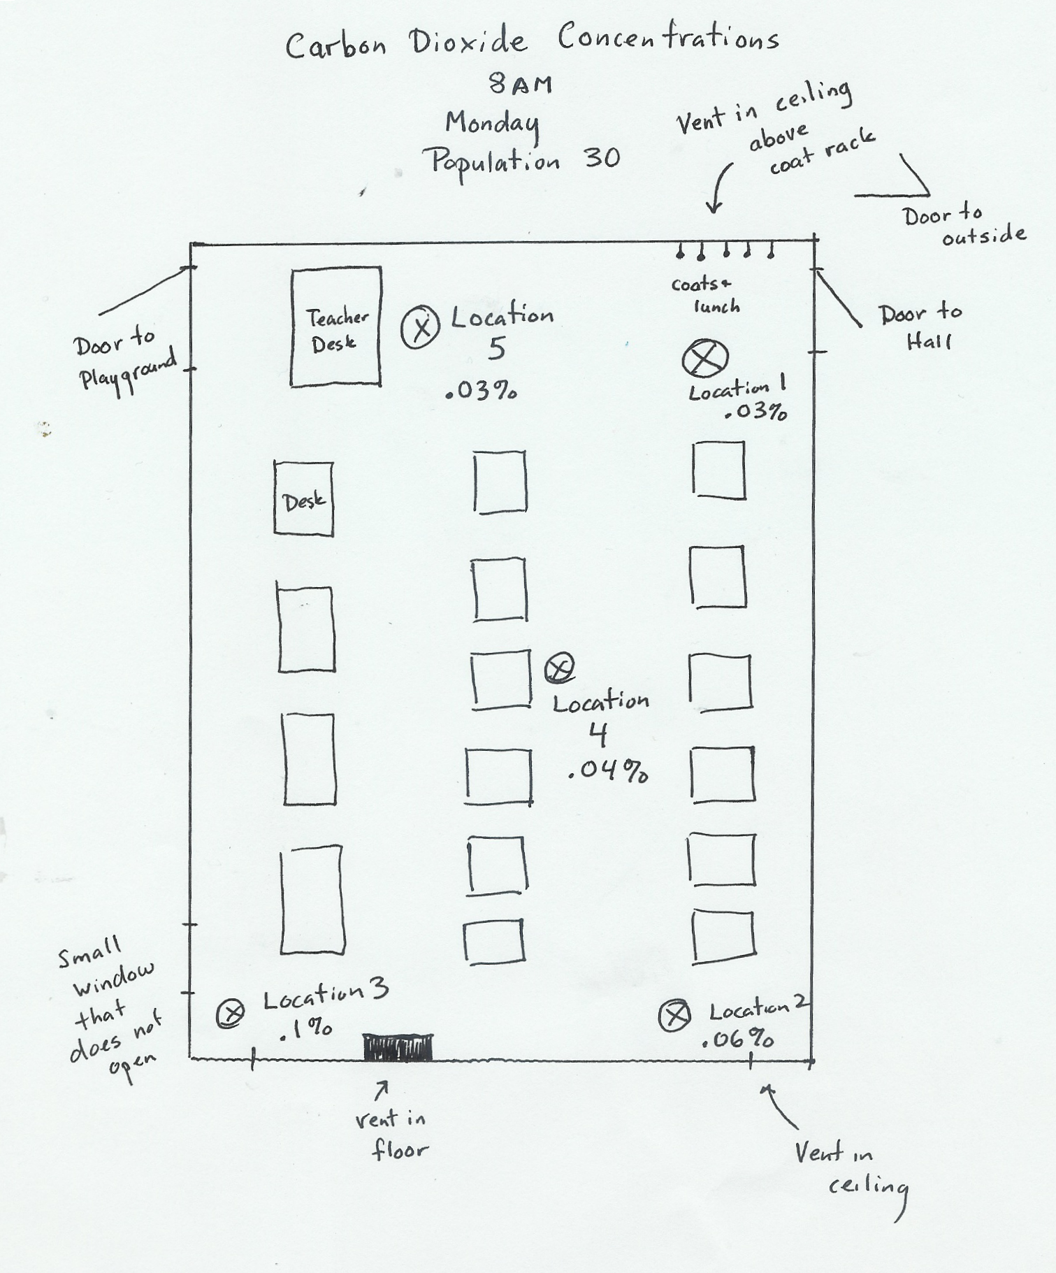

Discussion of Results:
In discussion, students must describe the cause for any changes in the concentration of carbon dioxide. The greater amount of data used in describing the pattern, the more likely it is to be accurate so encourage students to use measurements and observations from as many groups as possible. Here are some key ideas student may find evidence to support:

- Carbon dioxide concentrations may increase in enclosed spaces when no air is entering or exiting the room.
- Carbon dioxide concentrations may increase when the heating or cooling system is blowing re-circulated air into the room.
- Carbon dioxide concentration will most likely increase as population increases and is more active.
- Carbon dioxide concentrations fall rapid when outdoor air enters the room, assuming the air has natural baseline levels of carbon dioxide.

Assessment:
Prepare the procedures and design another investigation to isolate the variable that appears most responsible for increases in carbon dioxide levels.

Extensions:
- Collect data for all rooms in the school.
- Narrow the focus of the investigation to compare carbon dioxide concentrations with only time, population, season, temperature or level above the floor.

References:

EPA’s Indoor Air Quality Tools for Schools http://www.epa.gov/iaq/schools/

Carbon Dioxide Table from American Industrial Hygiene Association

GASTEC DVD (GAS DETECTOR TUBE SYSTEM, School teaching equipment)

Toxicity of Carbon Dioxide Gas Exposure, CO2 Poisoning Symptoms, Carbon Dioxide Exposure Limits, and Links to Toxic Gas Testing Procedures, Inspectapedia (Retrieved July, 2006) www.inspect-ny.com/hazmat/CO2gashaz.htm

